
MCULAF 2015 U.P. LAPEL PIN PROGRAM
EMPLOYEE PAYROLL DEDUCTION AUTHORIZATION FORM

To comply with state law the Michigan Credit Union League Action Fund (MCULAF) is the Michigan credit union movement’s Political Action Committee (PAC) organized for the purpose of making campaign contributions to candidates for elective office in the Michigan Legislature and other statewide elective offices. Contributions to MCULAF allow us to support candidates for elected offices who recognize the importance and value of credit unions.

I authorize my employer, to deduct the amount indicated below from my net pay during the 2015 calendar year on a bi-weekly basis and transmit that amount to MCULAF on my behalf until I provide written notice to suspend such contributions. If permitted by law, these contributions to MCULAF will continue until I provide written notice to my employer to end my contributions.

TWELVE MONTH PLAN (based on bi-weekly pay, 26 pay periods)

Pin Selection:

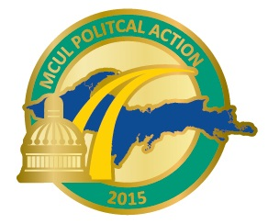
_____ $125 ($4.81 per pay) U.P. Chapter Gold Club
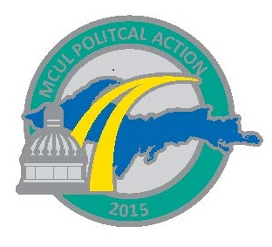

_____ $60 ($2.31 per pay) U.P. Chapter Silver Club

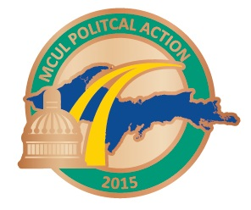
_____ $30 ($1.15 per pay) U.P. Chapter Bronze Club

❒ Please send me my 2015 pin  I already received my 2015 pin

Contributor Information:

Name: _________________________________________________________________________

Home Address: __________________________________________________________________

City/State/Zip: ___________________________________________________________________

Occupation: _____________________________________________________________________

Signature: __________________________________________ Date: _______________________

PLEASE RETURN COMPLETED FORM TO YOUR PAYROLL ADMINISTRATOR AND MAIL A COPY TO: MCULAF, ATTN: MELISSA OSBORN
101 S. WASHINGTON SQUARE, SUITE 900, LANSING, MI 48933

Affirmative Consent to Political Contribution: Section 55(6) of the Michigan Campaign Finance Act provides that a corporation, a joint stock company, a domestic dependent sovereign, or a labor organization “may solicit or obtain contributions for a separate segregated fund established on an automatic basis, including but not limited to a payroll deduction plan, only if the individual who is contributing to the fund affirmatively consents to the contribution at least once in every calendar year.” Contributions to MCULAF are not tax deductible. Contributions to MCULAF are completely voluntary and will be used for political purposes. You have the right to refuse to participate without any reprisal. Note: This communication is being sent to employees who are in professional, supervisory, managerial and administrative non-clerical positions or members of MCUL-affiliated credit unions. If you are not included in any of these categories please disregard this communication.

